MATHEMATICS LECTURES BY
MANISH KALIA
(B.TECH Delhi College of Engineering)
Lecture………date…………

CHAPTER 1:matrices
Basics of matrices
1.1

Definition 1 A matrix is an ordered rectangular array of numbers or functions. The numbers or functions are called the elements or the entries of the matrix
We denote matrices by capital letters. The following are some examples of matrices:

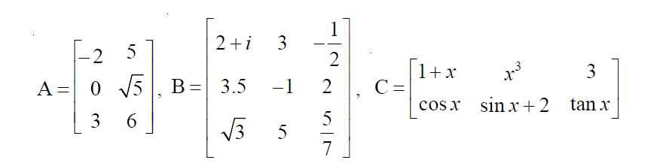
Order of a matrix
A matrix having m rows and n columns is called a matrix of order m × n or simply m × n matrix (read as an m by n matrix).
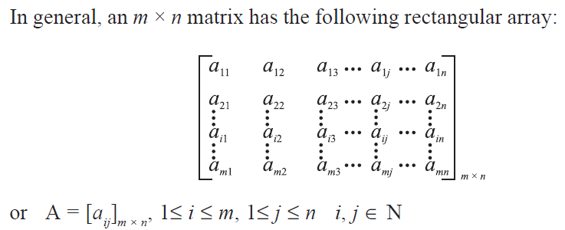

Types of Matrices

(i) Column matrix
A matrix is said to be a column matrix if it has only one column.
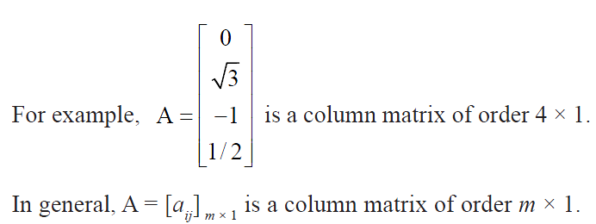
(ii) Row matrix

A matrix is said to be a row matrix if it has only one row.
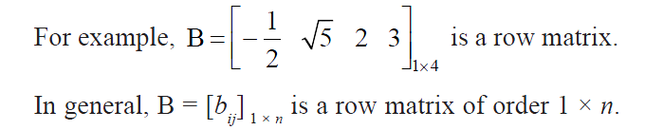
(iii) Square matrix
A matrix in which the number of rows are equal to the number of columns, is said to be a square matrix. Thus an m × n matrix is said to be a square matrix if m = n and is known as a square matrix of order ‘n’.
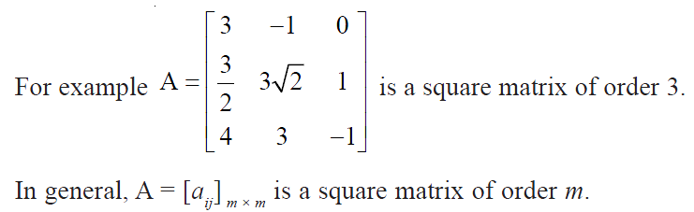
(iv) Diagonal matrix
A square matrix B = [bij] m × m is said to be a diagonal matrix if all its non diagonal elements are zero, that is a matrix B = [bij] m × m is said to be a diagonal matrix if bij = 0, when i ≠ j.
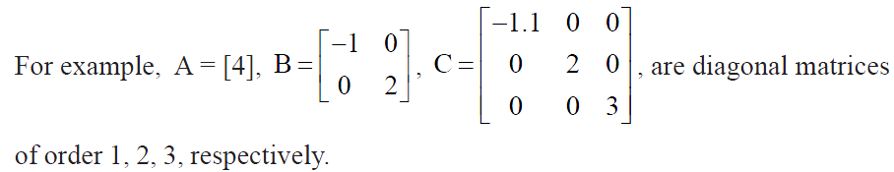

(v) Scalar matrix
A diagonal matrix is said to be a scalar matrix if its diagonal elements are equal, that is, a square matrix B = [bij] n × n is said to be a scalar matrix if
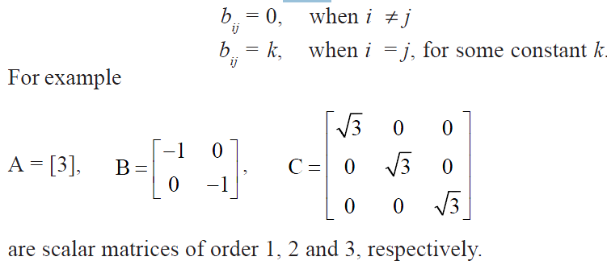

(vi) Identity matrix
A square matrix in which elements in the diagonal are all 1 and rest are all zero is called an identity matrix. In other words, the square matrix A = [aij] n × n is an
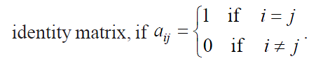
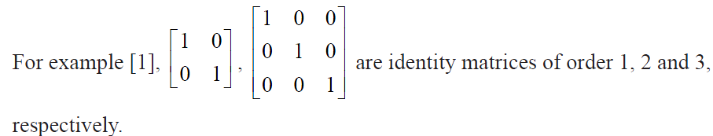
(vii) Zero matrix
A matrix is said to be zero matrix or null matrix if all its elements are zero.
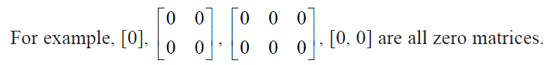

Equality of matrices
Two matrices A = [aij] and B = [bij] are said to be equal if
(i) they are of the same order
(ii) each element of A is equal to the corresponding element of B, that is aij = bij for
all i and j.

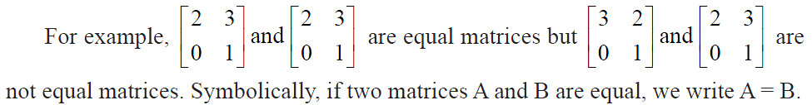

Operations on Matrices

1 Addition of matrices
If A = [aij] and B = [bij] are two matrices of the same order, say m × n. Then, the sum of the two matrices A and B is defined as a matrix C = [cij]m × n, where cij = aij + bij, for all possible values of i and j.

2 Multiplication of a matrix by a scalar
In general, we may define multiplication of a matrix by a scalar as follows: if A = [aij] m × n is a matrix and k is a scalar, then kA is another matrix which is obtained by multiplying each element of A by the scalar k.

3 Negative of a matrix
The negative of a matrix is denoted by –A. We define –A = (– 1) A.

4 Difference of matrices
If A = [aij], B = [bij] are two matrices of the same order, say m × n, then difference A – B is defined as a matrix D = [dij], where dij = aij – bij, for all value of i and j. In other words, D = A – B = A + (–1) B, that is sum of the matrix
A and the matrix – B.

Properties of matrix addition
(i) Commutative Law If A = [aij], B = [bij] are matrices of the same order, say m × n, then A + B = B + A.
(ii) Associative Law For any three matrices A = [aij], B = [bij], C = [cij] of the same order, say m × n, (A + B) + C = A + (B + C).
(iii) Existence of additive identity Let A = [aij] be an m × n matrix and O be an m × n zero matrix, then A + O = O + A = A.
(iv) The existence of additive inverse Let A = [aij]m × n be any matrix, then we have another matrix as – A = [– aij]m × n such that A + (– A) = (– A) + A= O. So – A is the additive inverse of A or negative of A.

Properties of scalar multiplication of a matrix
If A = [aij] and B = [bij] be two matrices of the same order, say m × n, and k and l are scalars, then
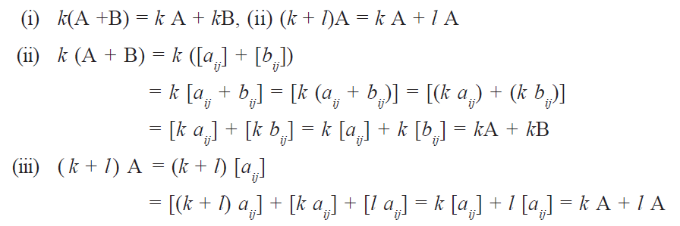

Multiplication of matrices

The product of two matrices A and B is defined if the number of columns of A is equal to the number of rows of B. Let A = [aij] be an m × n matrix and B = [bjk] be an n × p matrix. Then the product of the matrices A and B is the matrix C of order m × p. To get the (i, k)th element cik of the matrix C, we take the ith row of A and kth column of B, multiply them element wise and take the sum of all these products. In other words, if A = [aij]m × n, B = [bjk]n × p, then the ith row of A is [ai1 ai2 ... ain] and the kth column of B is
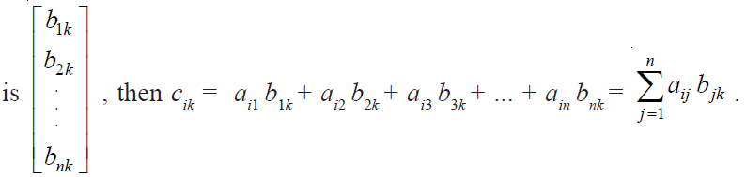
Remark If AB is defined, then BA need not be defined(Non-commutativity of multiplication of matrices)

Properties of multiplication of matrices
1. The associative law For any three matrices A, B and C. We have (AB) C = A (BC), whenever both sides of the equality are defined.
2. The distributive law For three matrices A, B and C.
(i) A (B+C) = AB + AC
(ii) (A+B) C = AC + BC, whenever both sides of equality are defined.
3. The existence of multiplicative identity For every square matrix A, there
exist an identity matrix of same order such that IA = AI = A.
Now, we shall verify these properties by examples.

 Exercise1.1
Q1: Construct a 3 × 2 matrix whose elements are given by 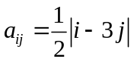?
Q2:
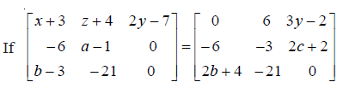Find a,b,c,x,y,z?
Q3:
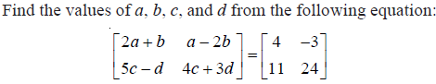
Q4:
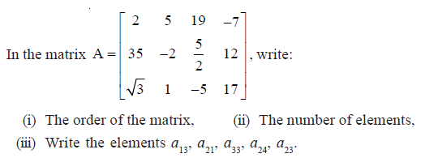
Q5:
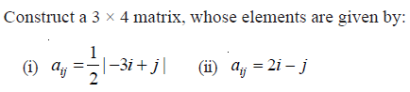
Q6:
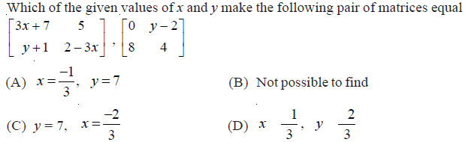
Q7:
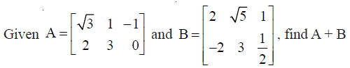
Q8:
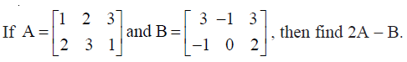
Q9:
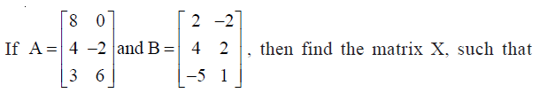
2A+3X=5B
Q10:
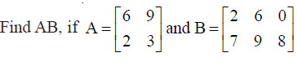

Q11:
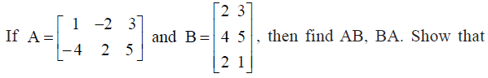
AB≠BA
Q12:
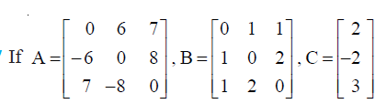
Q13:
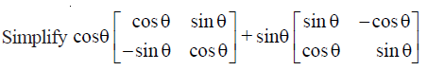
Exercise1.2
Q1: if 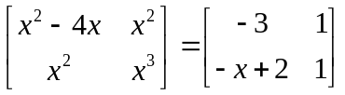.Find x?
Q2: Find the product of two matrices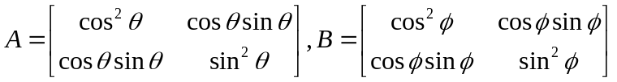
Show that AB is the zero matrix if θ & ∅ differ by an odd multiple of π/2.
Q3: if A & B are two matrices such that AB=B and BA=A,then 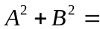
A)2AB B)2BA
C)A+B D)AB
Q4:If 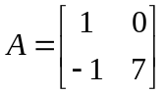 & 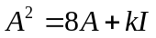,then K is
A)0 B)1
C)7 D)-7
Q5:If 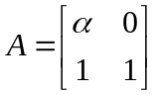 & 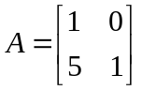 then the value of α is [IIT-2003]
A)1 B)-1
C)4 D)no real value
Q6:
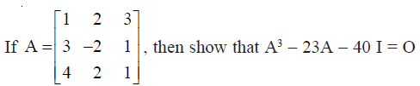
Q7:
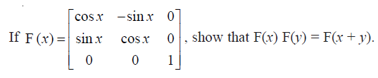
Q8:
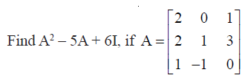
Q9:
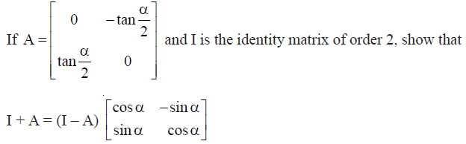 [Important]
Q10:A trust fund has Rs 30,000 that must be invested in two different types of bonds. The first bond pays 5% interest per year, and the second bond pays 7% interest per year. Using matrix multiplication, determine how to divide Rs 30,000 among the two types of bonds. If the trust fund must obtain an annual total interest of:
(a) Rs 1800 (b) Rs 2000 [Important]

